St. Paul’s Evangelical Lutheran Church
SUNDAY April 10th, 2021

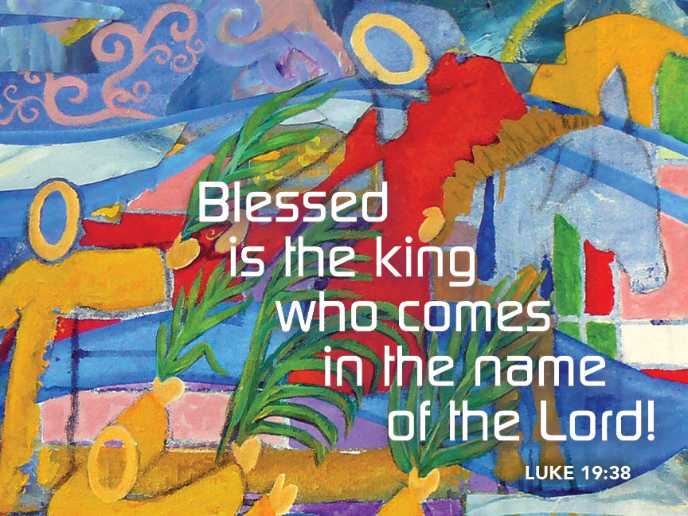

WELCOME

To our Church Family
We’re Glad You’re Here.

Today's Hymns from the Tower Church Carillon
The Westminster Strike
Announcements

Prelude: Lift High the Cross Sydney Hugo Nicholson
Arr. Sondra K. Tucker

(Words can be found in our hymnal, Evangelical Lutheran Worship, #660)

Camarada Brass Quintet
Chad Pittman, organ

Acclamation

Blessed is the one who comes in the name of the Lord.
Hosanna in the highest.

Processional Gospel: Luke 19:28-40

The holy gospel according to Luke.
Glory to you, O Lord.

²⁸After he had said this, [Jesus] went on ahead, going up to Jerusalem.
²⁹When he had come near Bethphage and Bethany, at the place called the Mount of Olives, he sent two of the disciples, ³⁰saying, “Go into the village ahead of you, and as you enter it you will find tied there a colt that has never been ridden. Untie it and bring it here. ³¹If anyone asks you, ‘Why are you untying it?’ just say this, ‘The Lord needs it.’ ” ³²So those who were sent departed and found it as he had told them. ³³As they were untying the colt, its owners asked them, “Why are you untying the colt?” ³⁴They said, “The Lord needs it.” ³⁵Then they brought it to Jesus; and after throwing their cloaks on the colt, they set Jesus on it. ³⁶As he rode along, people kept spreading their cloaks on the road. ³⁷As he was now approaching the path down from the Mount of Olives, the whole multitude of the disciples began to praise God joyfully with a loud voice for all the deeds of power that they had seen, ³⁸saying,
“Blessed is the king
who comes in the name of the Lord!
Peace in heaven,
and glory in the highest heaven!”
³⁹Some of the Pharisees in the crowd said to him, “Teacher, order your disciples to stop.” ⁴⁰He answered, “I tell you, if these were silent, the stones would shout out.”

The gospel of the Lord.
Praise to you, O Christ.
Blessing of Palms

The Lord be with you.
And also with you.
Let us pray.
We praise you, O God, for redeeming the world through our Savior Jesus Christ. Today he entered the holy city in triumph and was proclaimed messiah and king by those who spread garments and branches along his way. Bless these branches and those who carry them. Grant us grace to follow our Lord in the way of the cross, so that, joined to his death and resurrection, we enter into life with you; through the same Jesus Christ, who lives and reigns with you and the Holy Spirit, one God, now and forever.
Amen.

Let us go forth in peace,
in the name of Christ. Amen.
Prayer of the Day

As we now enter into the contemplation of the passion of our Lord Jesus Christ and meditate on the salvation of the world through his sufferings, death, burial, and resurrection, let us pray.
Silence is kept. Then the presiding minister prays the prayer of the day.
Everlasting God, in your endless love for the human race you sent our Lord Jesus Christ to take on our nature and to suffer death on the cross. In your mercy enable us to share in his obedience to your will and in the glorious victory of his resurrection, who lives and reigns with you and the Holy Spirit, one God, now and forever.
Amen.

First Reading: Isaiah 50:4-9a

A reading from Isaiah.
⁴The Lord God has given me
the tongue of a teacher,
that I may know how to sustain
the weary with a word.
Morning by morning he wakens—
wakens my ear
to listen as those who are taught.
⁵The Lord God has opened my ear,
and I was not rebellious,
I did not turn backward.
⁶I gave my back to those who struck me,
and my cheeks to those who pulled out the beard;
I did not hide my face
from insult and spitting.
⁷The Lord God helps me;
therefore I have not been disgraced;
therefore I have set my face like flint,
and I know that I shall not be put to shame;
⁸he who vindicates me is near.
Who will contend with me?
Let us stand up together.
Who are my adversaries?
Let them confront me.
^{9a}It is the Lord God who helps me;
who will declare me guilty?

The word of the Lord.
Thanks be to God.

Psalm: Psalm 31:9-16
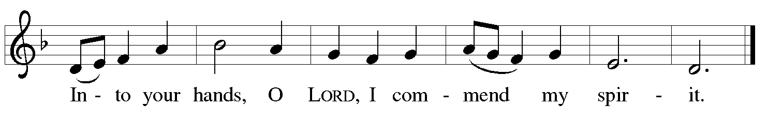
⁹Have mercy on me, O Lord, for I | am in trouble;
my eye is consumed with sorrow, and also my throat | and my belly.
¹⁰For my life is wasted with grief, and my | years with sighing;
my strength fails me because of affliction, and my bones | are
consumed.
¹¹I am the scorn of all my enemies, a disgrace to my neighbors, a dismay
to | my acquaintances;
when they see me in the street | they avoid me.
¹²Like the dead I am forgotten, | out of mind;
I am as useless as a | broken pot. R
¹³For I have heard the whispering of the crowd; fear is | all around;
they put their heads together against me; they plot to | take my life.
¹⁴But as for me, I have trusted in | you, O Lord.
I have said, “You | are my God.
¹⁵My times are | in your hand;
rescue me from the hand of my enemies, and from those
who | persecute me.
¹⁶Let your face shine up- | on your servant;
save me in your | steadfast love.” R

Second Reading: Philippians 2:5-11

A reading from Philippians.
⁵Let the same mind be in you that was in Christ Jesus,
⁶who, though he was in the form of God,
did not regard equality with God
as something to be exploited,
⁷but emptied himself,
taking the form of a slave,
being born in human likeness.
And being found in human form,
⁸he humbled himself
and became obedient to the point of death—
even death on a cross.
⁹Therefore God also highly exalted him
and gave him the name
that is above every name,
¹⁰so that at the name of Jesus
every knee should bend,
in heaven and on earth and under the earth,
¹¹and every tongue should confess
that Jesus Christ is Lord,
to the glory of God the Father.
The word of the Lord.
Thanks be to God.

Gospel Acclamation
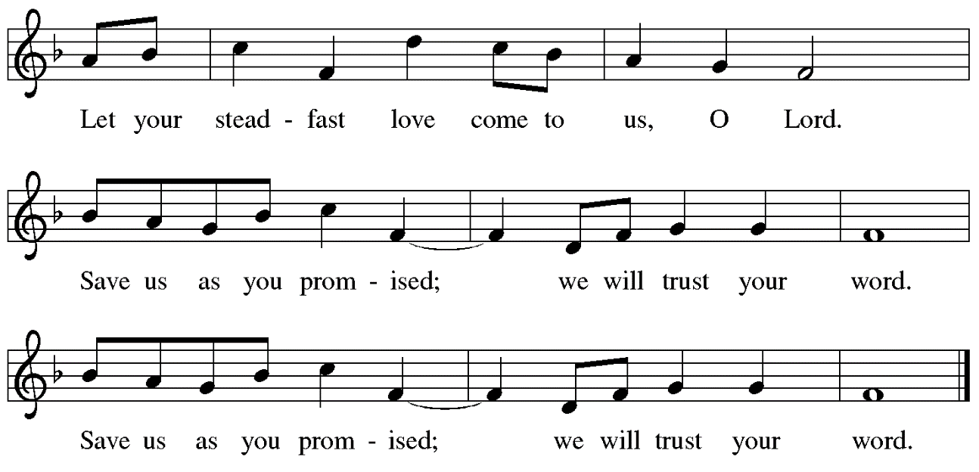

Gospel: Luke 23:1-49

The holy gospel according to Mark.
Glory to you, O Lord.

¹Then the assembly rose as a body and brought Jesus before Pilate. ²They began to accuse him, saying, “We found this man perverting our nation, forbidding us to pay taxes to the emperor, and saying that he himself is the Messiah, a king.” ³Then Pilate asked him, “Are you the king of the Jews?” He answered, “You say so.” ⁴Then Pilate said to the chief priests and the crowds, “I find no basis for an accusation against this man.” ⁵But they were insistent and said, “He stirs up the people by teaching throughout all Judea, from Galilee where he began even to this place.”
⁶When Pilate heard this, he asked whether the man was a Galilean. ⁷And when he learned that he was under Herod’s jurisdiction, he sent him off to Herod, who was himself in Jerusalem at that time. ⁸When Herod saw Jesus, he was very glad, for he had been wanting to see him for a long time, because he had heard about him and was hoping to see him perform some sign. ⁹He questioned him at some length, but Jesus gave him no answer. ¹⁰The chief priests and the scribes stood by, vehemently accusing him. ¹¹Even Herod with his soldiers treated him with contempt and mocked him; then he put an elegant robe on him, and sent him back to Pilate. ¹²That same day Herod and Pilate became friends with each other; before this they had been enemies.
¹³Pilate then called together the chief priests, the leaders, and the people, ¹⁴and said to them, “You brought me this man as one who was perverting the people; and here I have examined him in your presence and have not found this man guilty of any of your charges against him. ¹⁵Neither has Herod, for he sent him back to us. Indeed, he has done nothing to deserve death. ¹⁶I will therefore have him flogged and release him.”
¹⁸Then they all shouted out together, “Away with this fellow! Release Barabbas for us!” ¹⁹(This was a man who had been put in prison for an insurrection that had taken place in the city, and for murder.) ²⁰Pilate, wanting to release Jesus, addressed them again; ²¹but they kept shouting, “Crucify, crucify him!” ²²A third time he said to them, “Why, what evil has he done? I have found in him no ground for the sentence of death; I will therefore have him flogged and then release him.” ²³But they kept urgently demanding with loud shouts that he should be crucified; and their voices prevailed. ²⁴So Pilate gave his verdict that their demand should be granted. ²⁵He released the man they asked for, the one who had been put in prison for insurrection and murder, and he handed Jesus over as they wished.
²⁶As they led him away, they seized a man, Simon of Cyrene, who was coming from the country, and they laid the cross on him, and made him carry it behind Jesus. ²⁷A great number of the people followed him, and among them were women who were beating their breasts and wailing for him. ²⁸But Jesus turned to them and said, “Daughters of Jerusalem, do not weep for me, but weep for yourselves and for your children. ²⁹For the days are surely coming when they will say, ‘Blessed are the barren, and the wombs that never bore, and the breasts that never nursed.’ ³⁰Then they will begin to say to the mountains, ‘Fall on us’; and to the hills, ‘Cover us.’ ³¹For if they do this when the wood is green, what will happen when it is dry?”
³²Two others also, who were criminals, were led away to be put to death with him. ³³When they came to the place that is called The Skull, they crucified Jesus there with the criminals, one on his right and one on his left. ³⁴⟦Then Jesus said, “Father, forgive them; for they do not know what they are doing.”⟧ And they cast lots to divide his clothing. ³⁵And the people stood by, watching; but the leaders scoffed at him, saying, “He saved others; let him save himself if he is the Messiah of God, his chosen one!” ³⁶The soldiers also mocked him, coming up and offering him sour wine, ³⁷and saying, “If you are the King of the Jews, save yourself!” ³⁸There was also an inscription over him, “This is the King of the Jews.”
³⁹One of the criminals who were hanged there kept deriding him and saying, “Are you not the Messiah? Save yourself and us!” ⁴⁰But the other rebuked him, saying, “Do you not fear God, since you are under the same sentence of condemnation? ⁴¹And we indeed have been condemned justly, for we are getting what we deserve for our deeds, but this man has done nothing wrong.” ⁴²Then he said, “Jesus, remember me when you come into your kingdom.” ⁴³He replied, “Truly I tell you, today you will be with me in Paradise.”
⁴⁴It was now about noon, and darkness came over the whole land until three in the afternoon, ⁴⁵while the sun’s light failed; and the curtain of the temple was torn in two. ⁴⁶Then Jesus, crying with a loud voice, said, “Father, into your hands I commend my spirit.” Having said this, he breathed his last. ⁴⁷When the centurion saw what had taken place, he praised God and said, “Certainly this man was innocent.” ⁴⁸And when all the crowds who had gathered there for this spectacle saw what had taken place, they returned home, beating their breasts. ⁴⁹But all his acquaintances, including the women who had followed him from Galilee, stood at a distance, watching these things.

The gospel of the Lord.
Praise to you, O Christ.

Sermon Rev Mark Kreemer

Hymn of the Day Jesus, Keep Me Near the Cross ELW 335
Verse 1: All
Verse 2: Women’s Voices
Verse 3: Men’s Voices
Verse 4: All
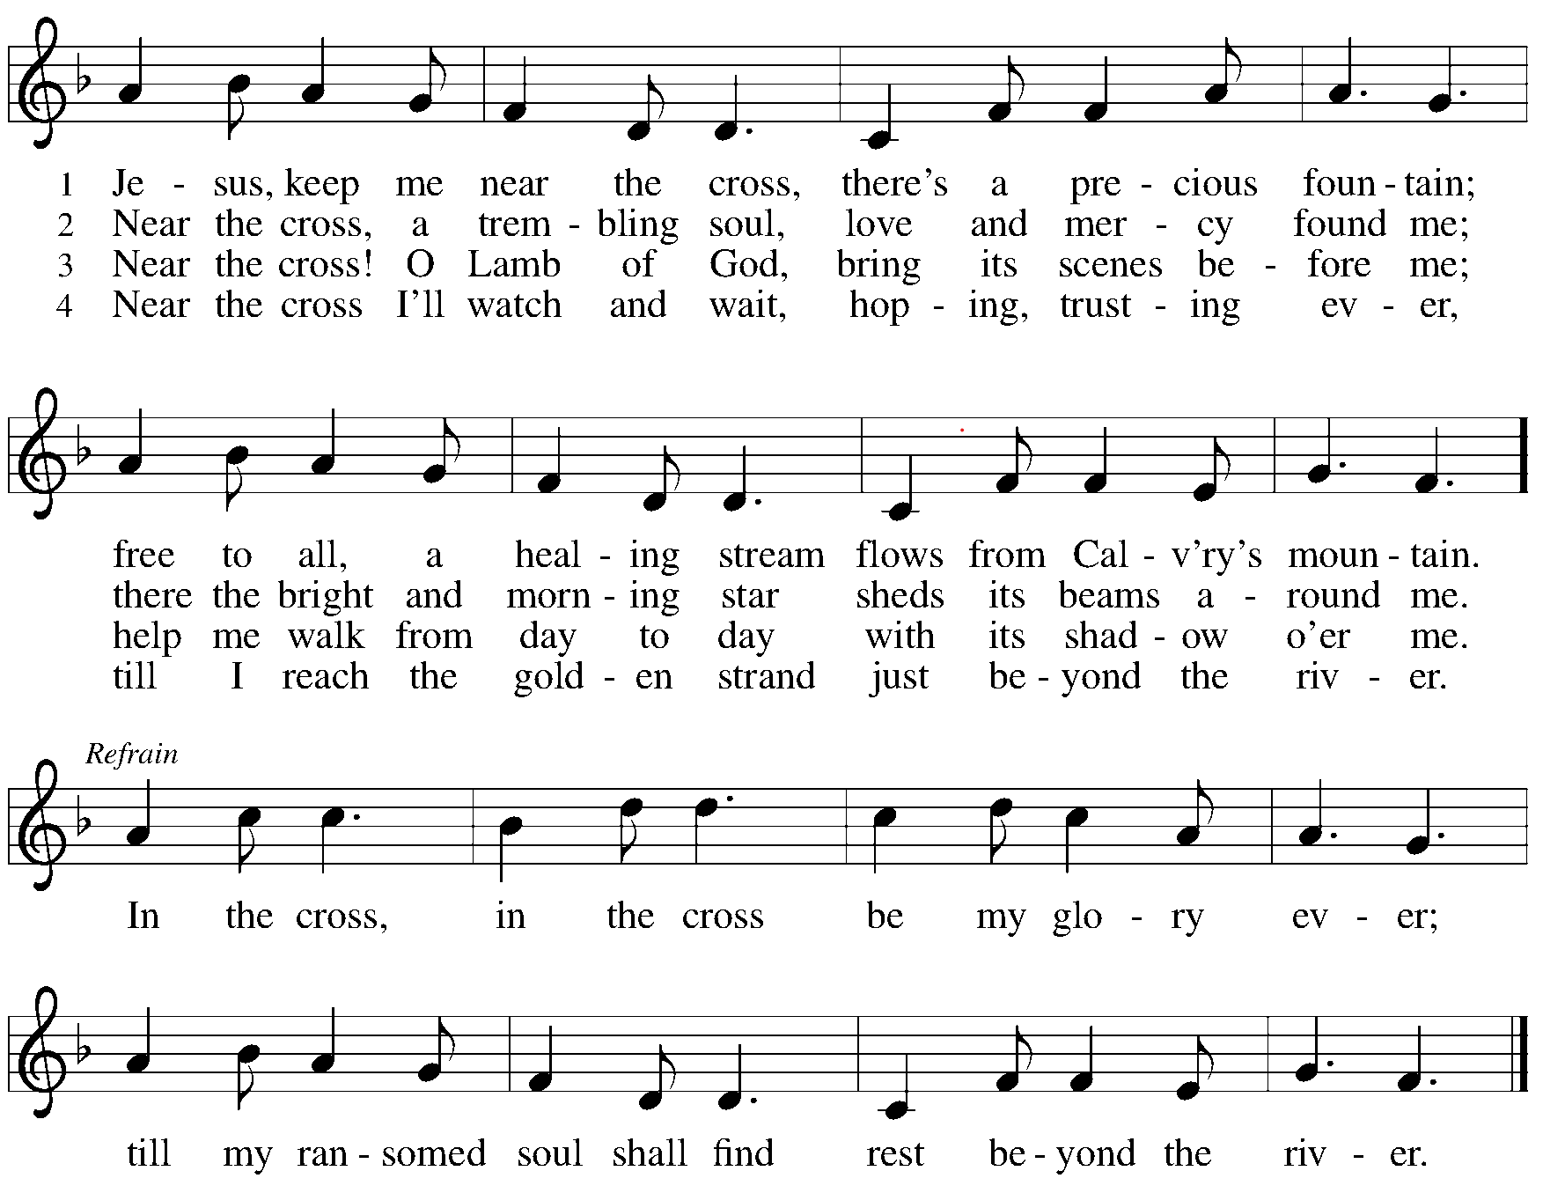
Creed

We believe in one God,
the Father, the Almighty,
maker of heaven and earth,
of all that is, seen and unseen.
We believe in one Lord, Jesus Christ,
the only Son of God,
eternally begotten of the Father,
God from God, Light from Light,
true God from true God,
begotten, not made,
of one Being with the Father;
through him all things were made.
For us and for our salvation
he came down from heaven,
was incarnate of the Holy Spirit and the virgin Mary
and became truly human.
For our sake he was crucified under Pontius Pilate;
he suffered death and was buried.
On the third day he rose again
in accordance with the scriptures;
he ascended into heaven
and is seated at the right hand of the Father.
He will come again in glory to judge the living and the dead,
and his kingdom will have no end.
We believe in the Holy Spirit, the Lord, the giver of life,
who proceeds from the Father and the Son,*
who with the Father and the Son is worshiped and glorified,
who has spoken through the prophets.
We believe in one holy catholic and apostolic church.
We acknowledge one baptism for the forgiveness of sins.
We look for the resurrection of the dead,
and the life of the world to come. Amen.
Prayers of Intercession

Drawn close to the heart of God, we offer these prayers for the church, the world, and all who are in need.
After each petition the following response is given:
Merciful God,
receive our prayer.

Accept the prayers we bring, O God, on behalf of a world in need, for the sake of Jesus Christ.
Amen.
Peace

The peace of Christ be with you always.
And also with you.

Offertory Anthem: God So Loved the World John Stainer
Albert Donze, baritone

John 3:16
For God so loved the world that He gave His only begotten Son,
That whosoever believeth in Him should not perish, but have everlasting life.
For God sent not His son into the world to condemn the world;
But that the world through Him might be saved.

Offering Prayer

Let us pray.
Extravagant God, you have blessed us with the fullness of creation. Now we gather at your feast where you offer us the food that satisfies. Take and use what we offer here, come among us, and feed us with the body and blood of Christ, in whose name we pray.
Amen.

Dialogue
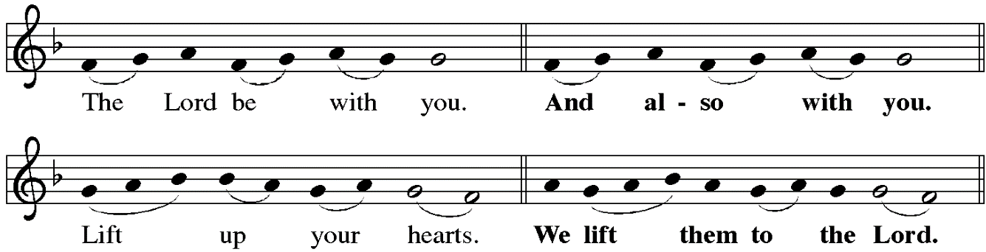
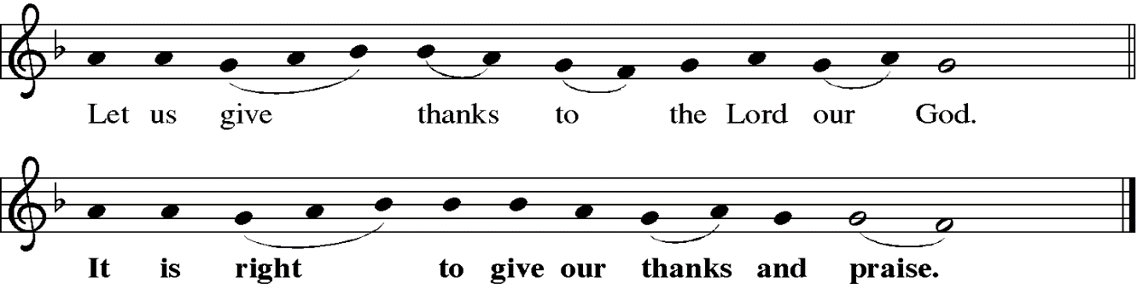

Preface
It is indeed right, our duty and our joy ... And so, with all the choirs of angels, with the church on earth and the hosts of heaven, we praise your name and join their unending hymn:

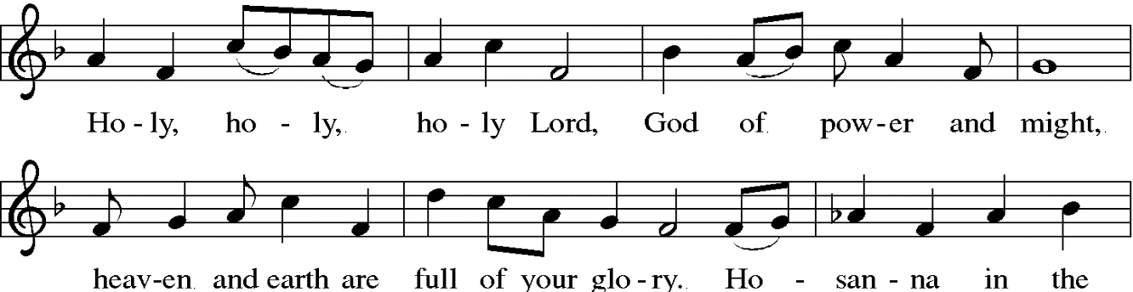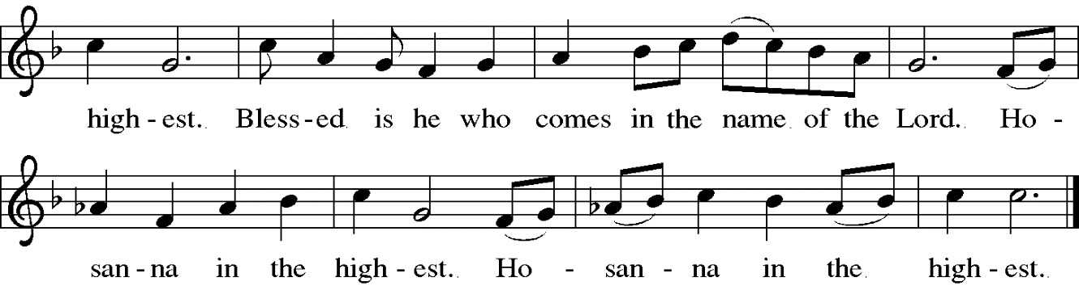
Thanksgiving at the Table: Lent

Holy God, our living Water and our merciful Guide, together with rivers and seas, wells and springs we bless and magnify you.

You led your people Israel through the desert, and provided them water from the rock. We praise you for Christ, our Rock and our Water, who joined us in our desert, pouring out his life for the world.

In the night in which he was betrayed, our Lord Jesus took bread, and gave thanks; broke it, and gave it to his disciples, saying: Take and eat; this is my body, given for you.
Do this for the remembrance of me.

Again, after supper, he took the cup, gave thanks, and gave it for all to drink, saying: This cup is the new covenant in my blood, shed for you and for all people for the forgiveness of sin.
Do this for the remembrance of me.

Remembering, therefore, his life, death, and resurrection, we await your salvation for all this thirsty world. Pour out your Spirit on this holy food and on all the baptized gathered for this feast: wash away our sin, that we may be revived for our journey by the love of Christ.

Through him all glory and honor is yours, Almighty Father, with the Holy Spirit, in your holy Church, both now and forever.
Amen

Lord’s Prayer

Gathered into one by the Holy Spirit, let us pray as Jesus taught us.
Our Father, who art in heaven,
hallowed be thy name,
thy kingdom come,
thy will be done,
on earth as it is in heaven.
Give us this day our daily bread;
and forgive us our trespasses,
as we forgive those
who trespass against us;
and lead us not into temptation,
but deliver us from evil.
For thine is the kingdom,
and the power, and the glory,
forever and ever. Amen.

Communion Song
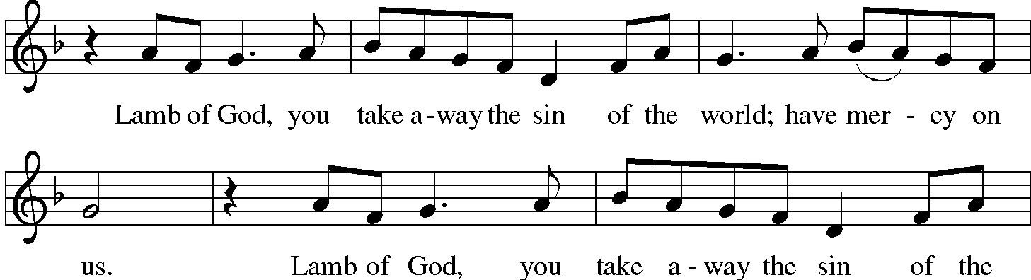
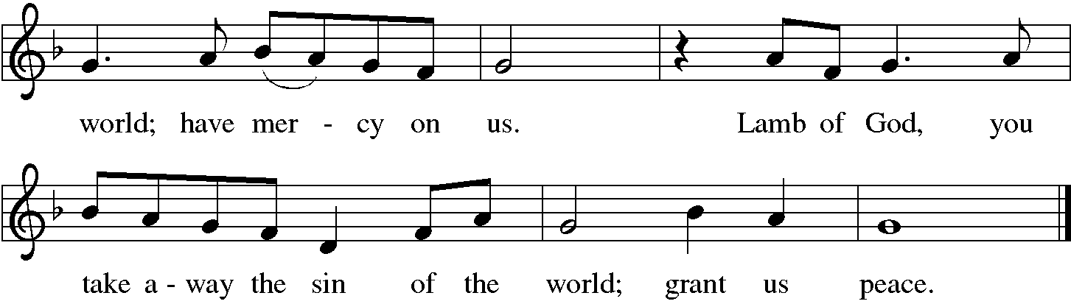

Communion Hymns Alas! And Did My Savior Bleed ELW 337
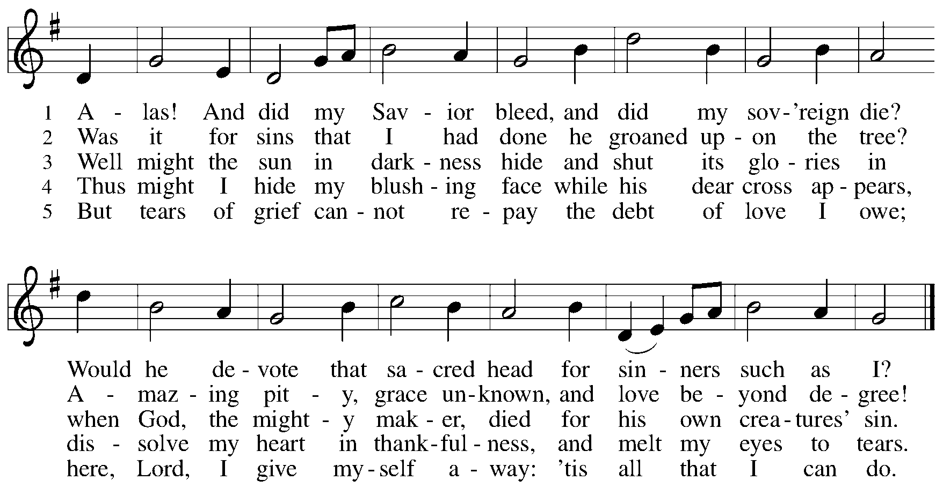

table blessing

May the body and blood of our lord Jesus Christ strengthen you and give you peace. Amen.

Prayer after Communion

Let us pray.
Blessed Jesus, in this rich meal of grace, you have fed us with your body, the bread of life. Now send us forth to bear your life-giving hope to a world in need.
Amen.

Sending HYMN Lift High the Cross ELW 660
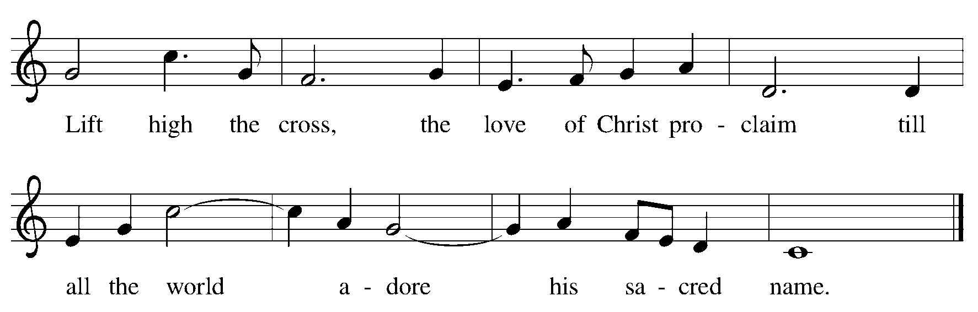

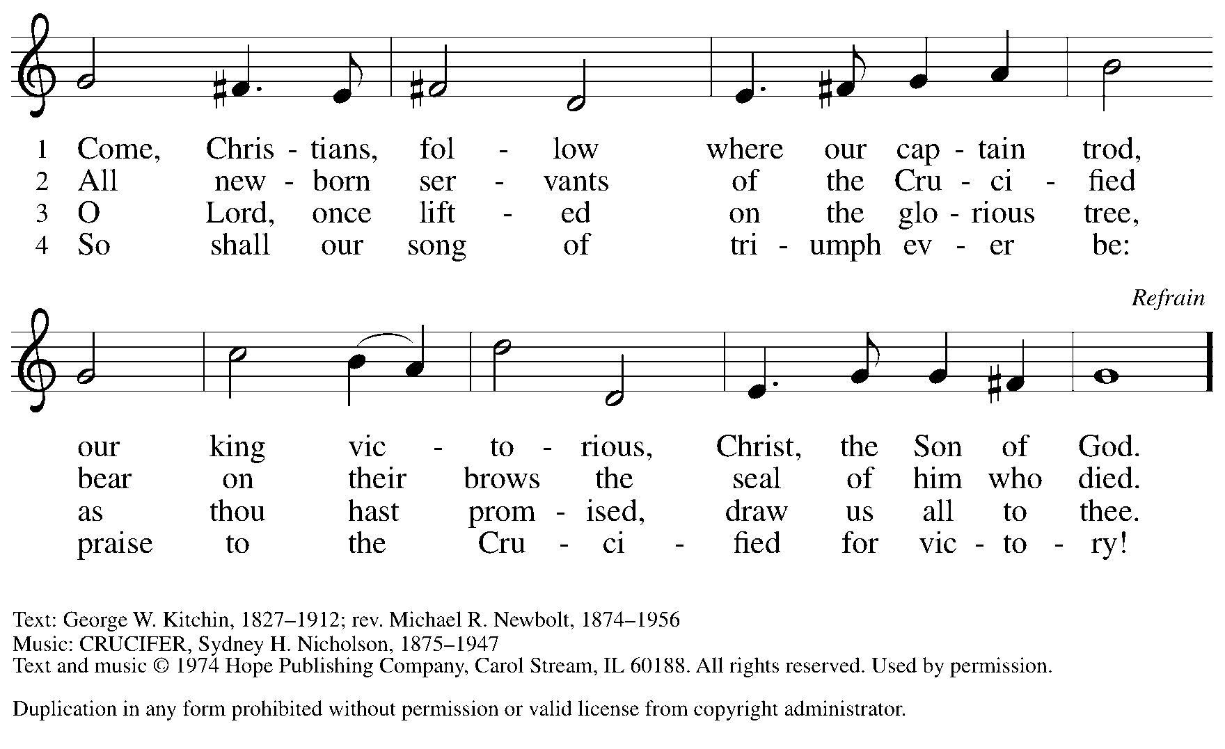

Blessing

May God who has called us forth from the dust of the earth, and claimed us as children of the light, strengthen you on your journey into life renewed.

The Lord bless you and keep you.
The Lord’s face shine upon you with grace and mercy.
The Lord look upon you with favor
and give you ☩ peace.
Amen.

Dismissal

Marked with the cross of Christ,
go forth to love and serve the Lord.
Thanks be to God.

Postlude: Festive Postlude on Old 100th (Doxology) Arr. Bruce A. Stevenson

Camarada Brass Quintet
Chad Pittman, organ

Music Notes

Special thanks to the Camarada Brass Quintet for joining us in worship today.

CAMARADA BRASS QUINTET
Jeff Huston-Trumpet I
Chris Hall-Trumpet II
Phil Tryon-French Horn
Matt Stemple-Trombone
Jonathon Stuck-Tuba

Musical offerings this Holy Week, including Easter, will include Sammy Kay Smith (soprano), Albert Donze (baritone), Chancel Choir Quartet, Dwight Butler (trumpet), Carol Butler (cello), and the Camarada Brass Quintet.

Flowers

Altar Flowers given by Scott and Darlene Lewis in honor of their 39th Wedding Anniversary.
Palm Branches are given by Bryan and Kathy Corban in honor Patsy & John Kindig and their parents.

In our prayers today we will remember

Bob Wilson, Jim Myers, Matthew Cottle, Russ Poling, Robert David Keefer, Barbara Korns, Amy White, Karen Painter, Robert Haas, Ann Pratt, Gloria Talarico, Chris Collard, Kyle Whelan, Ken Dexter, Chance Haines, Baby Caroline, Mike Zigelhoffer, Betty Ayers, Jim Dehnke, Pam Dekowski, Sherrie Whelan, Paula Kritzer, Lynne Nunley, , Cheryl Myers, Matthew Kronenwetter, Teri Dew, Mark Griffith, Mark Duris, Maria Garton, Carol Rohr, David Paul, Ray Jones, Renee Brown, Josh Keller, Sara Hughes, Chrissy Sturtz, Donna Viles, Jean Dexter, Bob Kirsch, Dan Landig, Anna Langenfeld, Karen Lunkwitz, Scott & Darlene Lewis, Angela Sutter, Maria Lictenberger, Ron Meimer, Hazel Draper, Jennifer Mays, Cheryl Shaw

Community Lenten Worship Services

Good Friday Community Service 12:00 noon at St Mary’s Catholic Church

Through the season of Lent, churches in the Massillon area will once again join together for worship, rotating locations and preachers. Our theme this year is “What I love about Jesus: Favorite Jesus stories.” We will follow the COVID protocols of each host congregation. Services begin at 6:30pm. Child care will be provided.

Offerings will go to the Family Living Center, a shelter and housing service in Massillon, and we will also be collecting new towels for them each week, as people bring them.

Thursday Morning Bible Study
Seeing Gray in a World of Black and White
Beginning April 6th

Seeing Gray in a World of Black and White is a hard-hitting call for Christians examine issues of political and social import with increased depth and acumen.
Everyone agrees that America is polarized, with ever-hardening positions held by people less and less willing to listen to one another. No one agrees on what to do about it.
One solution that hasn't yet been tried, says Adam Hamilton, is for thinking persons of faith to model for the rest of the country a richer, more thoughtful conversation on the political, moral, and religious issues that divide us. Hamilton rejects the easy assumptions and sloppy analysis of black and white thinking, seeking instead the truth that resides on all sides of the issues, and offering a faithful and compassionate way forward.

Altar Flowers

Please contact Sue Ambrosic at 330-832-5798 if you would like to have the Altar or Throne Flowers for 2022. Or sign up in the hallway across from the Gleitsman Lounge.

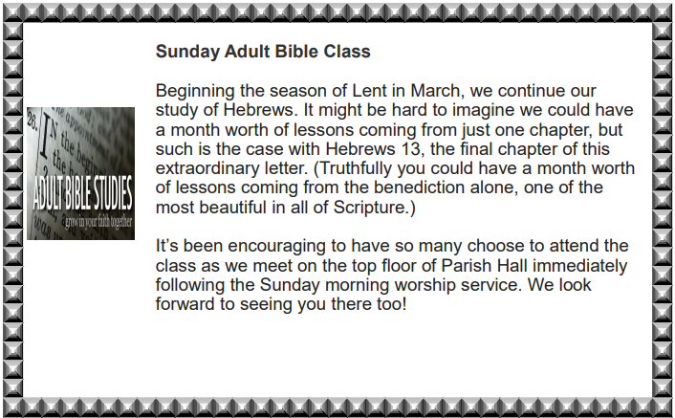

Hymns, Liturgies, and Live stream permissions granted by the following:
Augsburg Fortress Liturgies Annual License # SAS027923
Copyright © 2020 Augsburg Fortress. All rights reserved.

Gathering Song All Glory, Laud and Honor ELW 344
Public Domain

Hymn of the Day Jesus, Keep Me Near the Cross ELW 335
Public Domain

Communion Hymns Alas! And Did My Savior Bleed ELW 337
Public Domain

Sending HYMN Lift High the Cross ELW 660
"Permission to podcast / stream the music in this service obtained from ONE LICENSE, License #A-734490. All rights reserved

Thank you to those serving today:

Assisting Minister Karl Kalk

Lector Patty Long

Communion Asst Lea Lang & Greg Klein

Greeters

Ushers Greg and Lynda Klein
Adam & Jennifer Johnson

Soundboard Jim Johnson

Video/Live-Stream John Stanko

Cathedral Concerts in the Evening
Concert Series
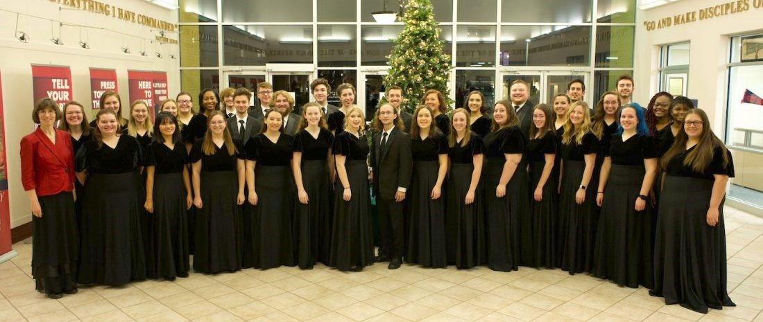

Malone University Choral Program

Saturday April 23, 2022 at 7:00 pm
The mission of the Malone University Chorale echoes the words of J.S. Bach: “The aim and final reason for all music should be nothing else but the glory of God and the refreshment of the spirit.” Through intense rehearsal and performance, the Chorale is motivated to prepare well and strive for excellence with a desire to make music that is an offering to the Lord. The Chorale functions in a way that seeks to represent the body of Christ. Its members strive to be Christ-like, serving and encouraging each other and those they meet.
The Malone University Chorale is a mixed chorus dedicated to the performance of sacred choral music reflecting diverse composers and cultures. Under the direction of Dr. Marin Jacobson, they are known throughout the United States and Europe for their high level of musical excellence. Members representing many paths of study are selected by audition each academic year.
The Chorale has performed domestically and internationally with destinations in Canada, Europe, Asia, and Latin America. Performance highlights include collaboration with the Canton Symphony Orchestra (Mahler’s Second Symphony and Brahms’ Ein deutsches Requiem), the Tuscarawas Philharmonic Symphony, and the beloved Christmas at Malone tradition. The Chorale was also the featured choral ensemble at the 2015 national conference of the Christian Fellowship of Art Music Composers.

Holy Week Services
Maundy Thursday April 14th 7:00 pm
Our Lenten observance comes to an end, and we gather with Christians around the world to celebrate the Three Days of Jesus’ death and resurrection. Tonight we remember Christ’s last meal with his disciples, but the central focus is his commandment that we live out the promise embodied in this meal. As Jesus washed his disciples’ feet, so we are called to give and receive love in humble service to one another.

Community Good Friday April 15th 12:00 pm
St Mary’s Catholic Church Stations of the Cross
The Stations of the Cross are a 14-step Catholic devotion that commemorates Jesus Christ's last day on Earth as a man. The 14 devotions, or stations, focus on specific events of His last day, beginning with His condemnation. The stations are commonly used as a mini pilgrimage as the individual moves from station to station. At each station, the individual recalls and meditates on a specific event from Christ's last day. Specific prayers are recited, then the individual moves to the next station until all 14 are complete.

St Paul’s Lutheran Church 7:00 pm Veneration of the Cross
The Veneration of the Cross on Good Friday can be traced back to fourth-century Jerusalem. The Pastor and congregation approach a cross or crucifix one by one, and offer a gesture of respect to all that it represents. This gesture usually includes kneeling or bowing before the cross and then kissing it. In medieval England and Germany people expressed their humility before Jesus' suffering and sacrificial death by approaching the cross on their hands and knees. This practice may have inspired an old folk name for the ceremony: "Creeping to the Cross" (for a similar custom practiced by Eastern Christians, see Sunday of the Veneration of the Holy Cross and Epitaphios).

Easter Morning April 17th 8:00 & 10:00 am
“The last enemy to be destroyed is death,” Paul writes. Today Christ is risen, and we gather together with astonishment and joy. Christ is risen, and we have been set free from the bonds of death. Christ is risen, and we are forgiven. Christ is risen, and with the women at the tomb and Peter, we are amazed. Let us rejoice:
Christ is risen indeed! Alleluia!

