St. Paul’s Evangelical Lutheran Church
Easter April 17th, 2022
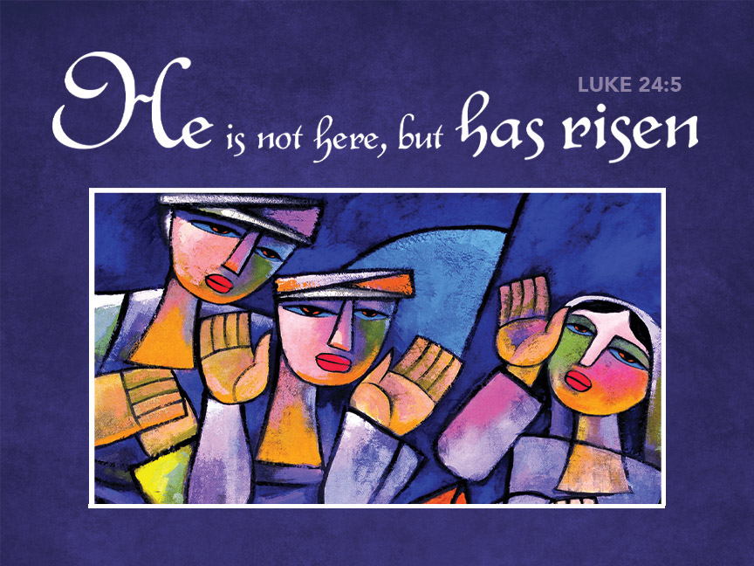

WELCOME

To our Church Family
We’re Glad You’re Here.

Today's Hymns from the Tower Church Carillon

Prelude: This Joyful Eastertide Arr. Sondra K. Tucker

Camarada Brass Quintet
Chad Pittman, organ

Thanksgiving for Baptism
All may make the sign of the cross, the sign that is marked at baptism, as the presiding minister begins.
Alleluia! Christ is risen.
Christ is risen indeed. Alleluia!

In the waters of baptism, we have passed over from death to life with Jesus Christ, and we are a new creation. For this saving mystery, and for this water, let us bless God,
who was, who is, and who is to come.
Water may be poured into the font as the presiding minister gives thanks.

We thank you, God, for your river of life, flowing freely from your throne:
through the earth, through the city, through every living thing.

You rescued Noah and his family from the flood; You opened wide the sea for the Israelites.
Now in these waters you flood us with mercy, and our sin is drowned forever.
You open the gate of righteousness and we pass safely through.

In Jesus Christ, you calm and trouble the waters. You nourish us and enclose us in safety.
You call us forth and send us out. In lush and barren places, you are with us.
You have become our salvation.

Now breathe upon this water and awaken your church once more.
Claim us again as your beloved and holy people.
Quench our thirst; cleanse our hearts; wipe away every tear.

To you, our Beginning and our End, our Shepherd and Lamb,
be honor, glory, praise, and thanksgiving, now and forever.
Amen.

Gathering Song Jesus Christ Is Risen Today ELW 365

Greeting

Alleluia! Christ is risen!
Christ is risen indeed! Alleluia!

The grace of our Lord Jesus Christ, the love of God,
and the communion of the Holy Spirit be with you all.
And also with you.

Canticle of Praise .

Prayer of the Day

Let us pray.
O God, you gave your only Son to suffer death on the cross for our redemption, and by his glorious resurrection you delivered us from the power of death. Make us die every day to sin, that we may live with him forever in the joy of the resurrection, through your Son, Jesus Christ our Lord, who lives and reigns with you and the Holy Spirit, one God, now and forever. Amen.

Anthem: Crown Him Dan Forrest

(Words can be found in our hymnal, Evangelical Lutheran Worship, #855)

Chancel Choir Quartet
Camarada Brass Quintet

First Reading: Acts 10:34–43

³⁴Then Peter began to speak to them: "I truly understand that God shows no partiality, ³⁵but in every nation anyone who fears him and does what is right is acceptable to him. ³⁶You know the message he sent to the people of Israel, preaching peace by Jesus Christ — he is Lord of all. ³⁷That message spread throughout Judea, beginning in Galilee after the baptism that John announced: ³⁸how God anointed Jesus of Nazareth with the Holy Spirit and with power; how he went about doing good and healing all who were oppressed by the devil, for God was with him. ³⁹We are witnesses to all that he did both in Judea and in Jerusalem. They put him to death by hanging him on a tree; ⁴⁰but God raised him on the third day and allowed him to appear, ⁴¹not to all the people but to us who were chosen by God as witnesses, and who ate and drank with him after he rose from the dead. ⁴²He commanded us to preach to the people and to testify that he is the one ordained by God as judge of the living and the dead. ⁴³All the prophets testify about him that everyone who believes in him receives forgiveness of sins through his name."

The word of the Lord.
Thanks be to God.

Psalm: Psalm 118:1-2, 14-24
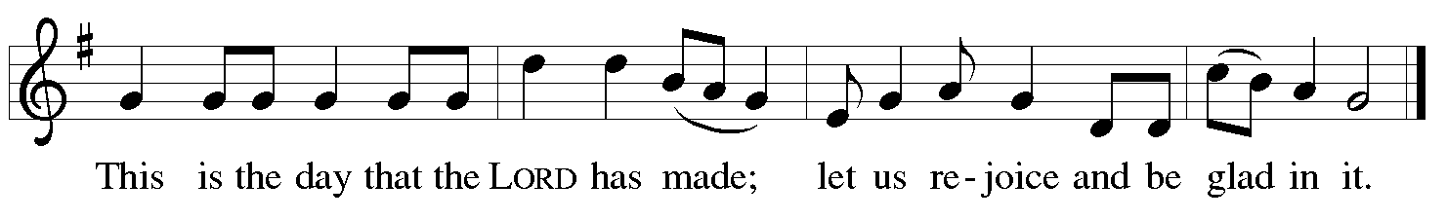
¹Give thanks to the Lord, for the | Lord is good;
God’s mercy en- | dures forever.
²Let Israel | now declare,
“God’s mercy en- | dures forever.”
¹⁴The Lord is my strength | and my song,
and has become | my salvation.
¹⁵Shouts of rejoicing and salvation echo in the tents | of the righteous:
“The right hand of the | Lord acts valiantly!
¹⁶The right hand of the Lord| is exalted!
The right hand of the | Lord acts valiantly!”
¹⁷I shall not | die, but live,
and declare the works | of the Lord. R
¹⁸The Lord indeed pun- | ished me sorely,
but did not hand me o- | ver to death.
¹⁹Open for me the | gates of righteousness;
I will enter them and give thanks | to the Lord.
²⁰“This is the gate | of the Lord;
here the righ- | teous may enter.”
²¹I give thanks to you, for you have | answered me
and you have become | my salvation. R
²²The stone that the build- | ers rejected
has become the chief | cornerstone.
²³By the Lord has | this been done;
it is marvelous | in our eyes.
²⁴This is the day that the | Lord has made;
let us rejoice and be | glad in it. R

Second Reading: 1 Corinthians 15:19-26

¹⁹If for this life only we have hoped in Christ, we are of all people most to be pitied.
²⁰But in fact Christ has been raised from the dead, the first fruits of those who have died. ²¹For since death came through a human being, the resurrection of the dead has also come through a human being; ²²for as all die in Adam, so all will be made alive in Christ. ²³But each in his own order: Christ the first fruits, then at his coming those who belong to Christ. ²⁴Then comes the end, when he hands over the kingdom to God the Father, after he has destroyed every ruler and every authority and power. ²⁵For he must reign until he has put all his enemies under his feet. ²⁶The last enemy to be destroyed is death.

The word of the Lord.
Thanks be to God.

Gospel Acclamation

Gospel: Luke 24:1-12

The holy gospel according to Luke, the 24th chapter.
Glory to you, O Lord.

On the first day of the week, at early dawn, [the women] came to the tomb, taking the spices that they had prepared. ²They found the stone rolled away from the tomb, ³but when they went in, they did not find the body. ⁴While they were perplexed about this, suddenly two men in dazzling clothes stood beside them. ⁵The women were terrified and bowed their faces to the ground, but the men said to them, “Why do you look for the living among the dead? He is not here, but has risen. ⁶Remember how he told you, while he was still in Galilee, ⁷that the Son of Man must be handed over to sinners, and be crucified, and on the third day rise again.” ⁸Then they remembered his words, ⁹and returning from the tomb, they told all this to the eleven and to all the rest. ¹⁰Now it was Mary Magdalene, Joanna, Mary the mother of James, and the other women with them who told this to the apostles. ¹¹But these words seemed to them an idle tale, and they did not believe them. ¹²But Peter got up and ran to the tomb; stooping and looking in, he saw the linen cloths by themselves; then he went home, amazed at what had happened.

The gospel of the Lord.
Praise to you, O Christ.
Sermon Rev Mark Kreemer

Hymn of the Day Christ Is Risen! Alleluia! ELW 382
Creed .
I believe in God, the Father almighty,
creator of heaven and earth.

I believe in Jesus Christ, God’s only Son, our Lord,
who was conceived by the Holy Spirit,
born of the virgin Mary,
suffered under Pontius Pilate,
was crucified, died, and was buried;
he descended to the dead.*
On the third day he rose again;
he ascended into heaven,
he is seated at the right hand of the Father,
and he will come to judge the living and the dead.

I believe in the Holy Spirit,
the holy catholic church,
the communion of saints,
the forgiveness of sins,
the resurrection of the body,
and the life everlasting. Amen.

*Or, “he descended into hell,” another translation of this text in widespread use.

Prayers of Intercession

On this day of resurrection joy, let us offer our prayers for ourselves, our neighbors, and our world..

After each petition the following response is given:
Merciful God,
receive our prayer.

We offer to you these petitions and those we carry in our hearts, trusting in your abundant and ever-present mercy.
Amen.

Peace .
The peace of Christ be with you always.
And also with you.

Offertory Anthem: I Know that My Redeemer Liveth from Messiah
George Frideric Handel

Sammy Kay Smith, soprano

Offering Prayer

Living God, you gather the wolf and the lamb to feed together in your peaceable reign, and you welcome us all at your table. Reach out to us through this meal, and show us your wounded and risen body, that we may be nourished and believe in Jesus Christ, our Savior and Lord. Amen.

Great Thanksgiving

It is indeed right, our duty and our joy, that we should at all times and in all places…. And so, with all the choirs of angels, with the church on earth and the hosts of heaven, we praise your name and join their unending hymn:
EUCHARISTIC PRAYER

Blessed are you, O God of the universe. Your mercy is everlasting and your faithfulness endures from age to age.

Praise to you for creating the heavens and the earth.
Praise to you for saving the earth from the waters of the flood.
Praise to you for bringing the Israelites safely through the sea.
Praise to you for leading your people through the wilderness
to the land of milk and honey.
Praise to you for the words and deeds of Jesus, your anointed one.
Praise to you for the death and resurrection of Christ.
Praise to you for your Spirit poured out on all nations.

In the night in which he was betrayed, our Lord Jesus took bread, and gave thanks; broke it, and gave it to his disciples, saying: Take and eat; this is my body, given for you.
Do this for the remembrance of me.

Again, after supper, he took the cup, gave thanks, and gave it for all to drink, saying: This cup is the new covenant in my blood, shed for you and for all people for the forgiveness of sin. Do this for the remembrance of me.

With this bread and cup we remember our Lord's passover from death to life as we proclaim the mystery of faith:
Christ has died. Christ is risen. Christ will come again.

O God of resurrection and new life: Pour out your Holy Spirit on us and on these gifts of bread and wine. Bless this feast. Grace our table with your presence.
Come, Holy Spirit.

Reveal yourself to us in the breaking of the bread. Raise us up as the body of Christ for the world. Breathe new life into us. Send us forth, burning with justice, peace, and love.
Come, Holy Spirit.

With your holy ones of all times and places, with the earth and all its creatures, with sun and moon and stars, we praise you, O God, blessed and holy Trinity,
now and forever. Amen.

Lord's Prayer

Our Father, who art in heaven,
hallowed be thy name, thy kingdom come,
thy will be done, on earth as it is in heaven.
Give us this day our daily bread;
and forgive us our trespasses,
as we forgive those who trespass against us;
and lead us not into temptation, but deliver us from evil.
For thine is the kingdom,
and the power, and the glory,
forever and ever. Amen.

Invitation to Communion

The risen Christ dwells with us here.
All who are hungry, all who are thirsty, come.

Communion Hymns

Awake, My Heart, with Gladness ELW 378
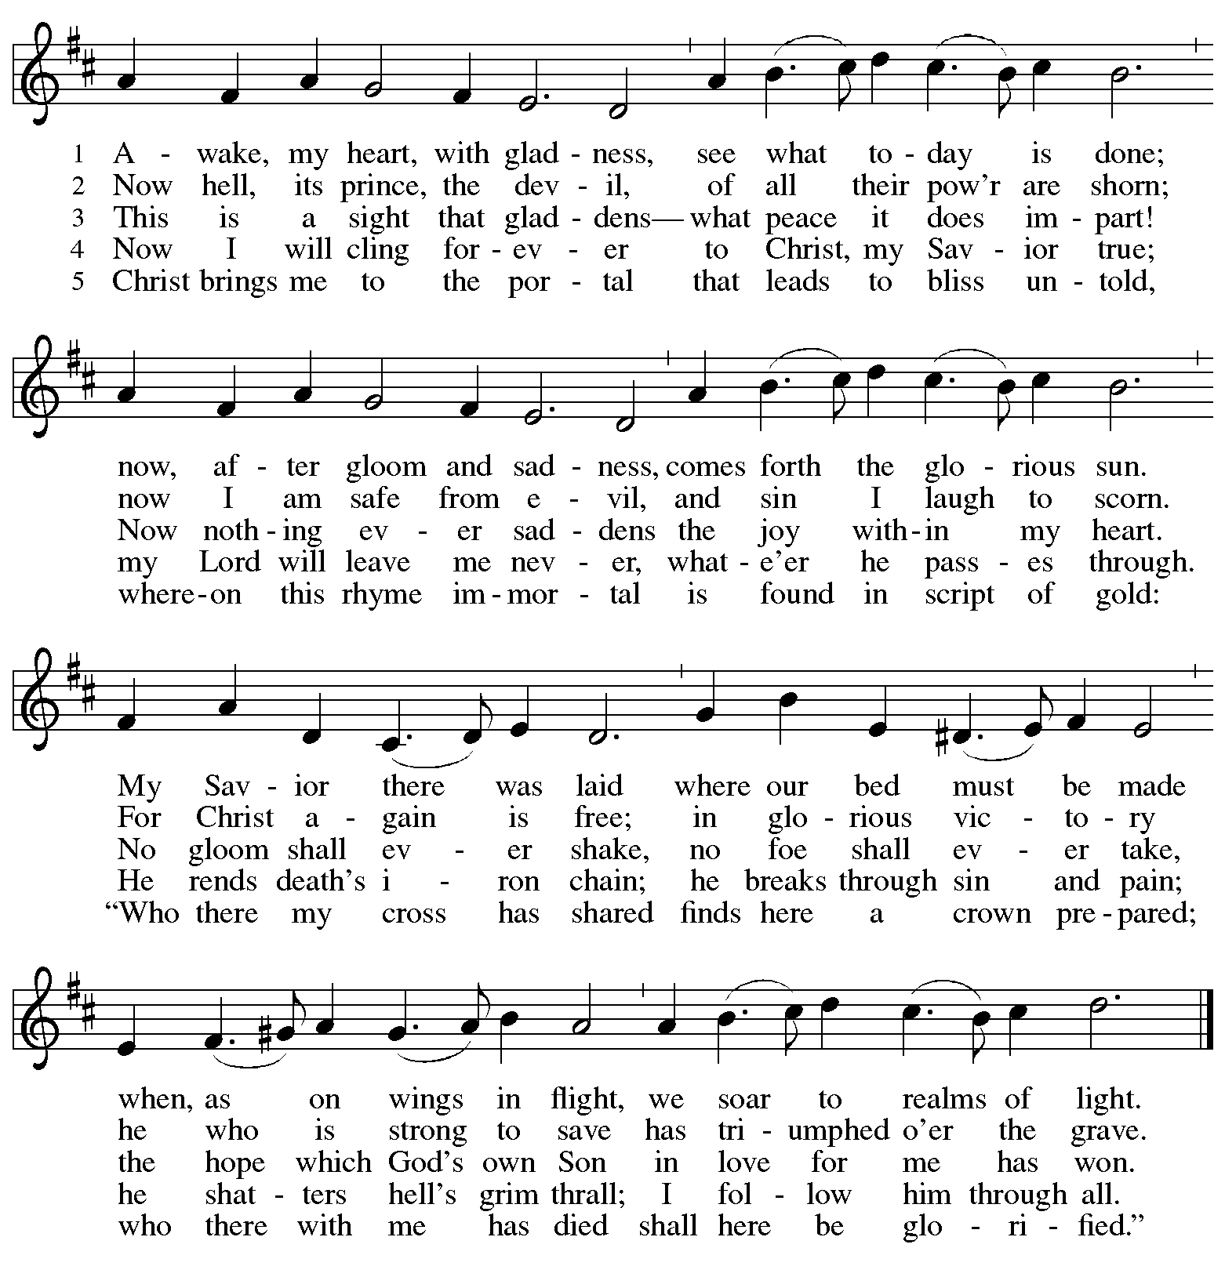

Good Christian Friends Rejoyce and Sing ELW 385
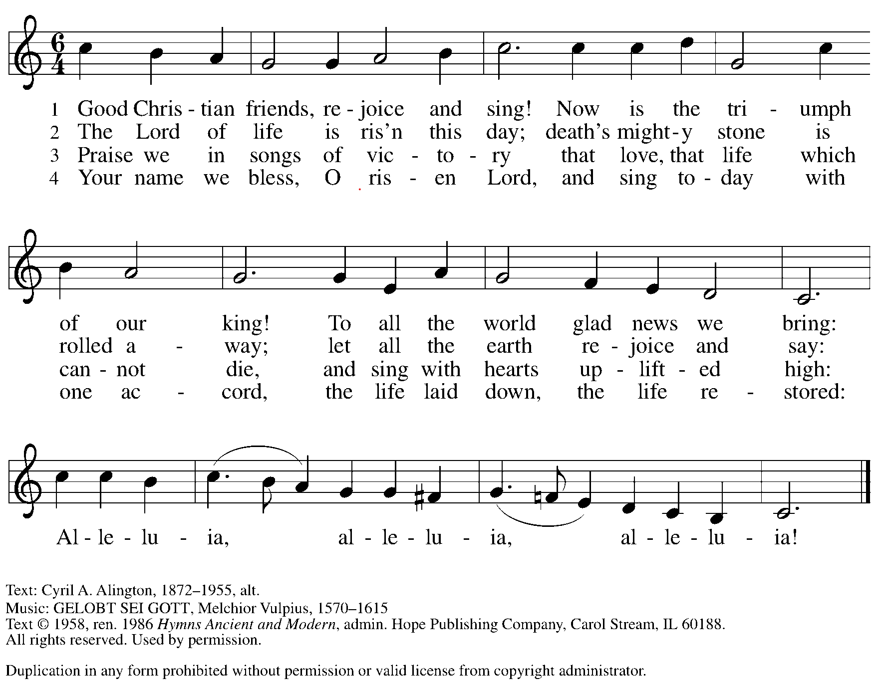

TABLE BLESSING

The body and blood of our Lord Jesus Christ strengthen you and keep you in his grace.
Amen.

Prayer after Communion

We give you thanks, generous God, for in this bread and cup we have tasted the new heaven and earth where hunger and thirst are no more. Send us from this table as witnesses to the resurrection, that through our lives, all may know life in Jesus’ name.
Amen.

sending Hymn: The Strife is O’er, the Battle Done ELW 366

Blessing

God, the Author of life, Christ, the living Cornerstone,
and the life-giving Spirit of adoption, ☩ bless you now and forever.
Amen.

Dismissal

Alleluia! Christ is risen.
Christ is risen indeed. Alleluia!

Go in peace. Tell what God has done.
Thanks be to God.
Postlude: Toccata from Symphony V Charles-Marie Widor

Music Notes
Special thanks to the Camarada Brass Quintet for joining us in worship today.

CAMARADA BRASS QUINTET
Jeff Huston-Trumpet I
Chris Hall-Trumpet II
Phil Tryon-French Horn
Matt Stemple-Trombone
Jonathon Stuck-Tuba

Postlude: Toccata from Symphony V by Charles Marie Widor is one of the most widely played selections in the organ repertoire. Common during wedding ceremonies, it is most frequently a majestic postlude on Easter Sunday. Featuring fast-moving arpeggios and steady chords passed between the hands with the melody in the pedal, the opening registration is almost full organ. The organist waits to activate full organ until the end of the piece when every stop of the organ is utilized to assist in an exciting culminating finale. Modern organists play it much faster than Widor ever intended. In fact, Widor plays his toccata at half the speed of most modern interpretations. Called his “f-minor” sonata, the full Symphony is thirty-five minutes long, featuring five full movements in contrasting style and tempo. Widor wrote eight symphonies in all.

Flowers:
Altar Flowers are donated today by Judy & Chris Hall in honor of their 51st Wedding Anniversary.

In our prayers today we will remember

Joe Hepler, Bob Wilson, Jim Myers, Matthew Cottle, Russ Poling, Robert David Keefer, Barbara Korns, Amy White, Karen Painter, Robert Haas, Ann Pratt, Gloria Talarico, Chris Collard, Kyle Whelan, Ken Dexter, Chance Haines, Baby Caroline, Mike Zigelhoffer, Betty Ayers, Jim Dehnke, Pam Dekowski, Sherrie Whelan, Paula Kritzer, Lynne Nunley, , Cheryl Myers, Matthew Kronenwetter, Teri Dew, Mark Griffith, Mark Duris, Maria Garton, Carol Rohr, David Paul, Ray Jones, Renee Brown, Josh Keller, Sara Hughes, Chrissy Sturtz, Donna Viles, Jean Dexter, Bob Kirsch, Dan Landig, Anna Langenfeld, Karen Lunkwitz, Scott & Darlene Lewis, Angela Sutter, Maria Lictenberger, Ron Meimer, Hazel Draper, Jennifer Mays, Cheryl Shaw

Hymns, Liturgies, and Live stream permissions granted by the following:

Augsburg Fortress Liturgies Annual License # SAS027923
Copyright © 2020 Augsburg Fortress. All rights reserved.

Gathering Song Jesus Christ is Risen Today! ELW 365
PUBLIC DOMAIN

Hymn of the Day Christ is Risen, Alleluia ELW 382
PUBLIC DOMAIN

Communion Hymns
Awake, My Heart, with Gladness ELW 378
PUBLIC DOMAIN
Good Christian Friends Rejoyce and Sing ELW 385
"Permission to podcast / stream the music in this service obtained from ONE LICENSE, License #A-734490. All rights reserved

RECESSIONAL HYMN The Strife is O’er, The Battle Done ELW 376
PUBLIC DOMAIN

Thursday Morning Bible Study
Seeing Gray in a World of Black and White
Beginning April 6th

Seeing Gray in a World of Black and White is a hard-hitting call for Christians examine issues of political and social import with increased depth and acumen.
Everyone agrees that America is polarized, with ever-hardening positions held by people less and less willing to listen to one another. No one agrees on what to do about it.
One solution that hasn't yet been tried, says Adam Hamilton, is for thinking persons of faith to model for the rest of the country a richer, more thoughtful conversation on the political, moral, and religious issues that divide us. Hamilton rejects the easy assumptions and sloppy analysis of black and white thinking, seeking instead the truth that resides on all sides of the issues, and offering a faithful and compassionate way forward.

Altar Flowers

Please contact Sue Ambrosic at 330-832-5798 if you would like to have the Altar or Throne Flowers for 2022. Or sign up in the hallway across from the Gleitsman Lounge.

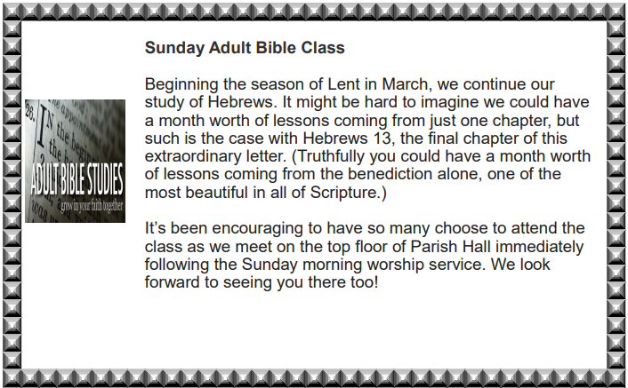

Thank you to those serving today:

Assisting Minister Scott Larson

Lector Patty Long

Communion Asst Patty Long & Tracie Schmolt

Greeters

Ushers Greg and Lynda Klein
Adam & Jennifer Johnson

Soundboard Jim Johnson

Video/Live-Stream John Stanko

Cathedral Concerts in the Evening
Concert Series
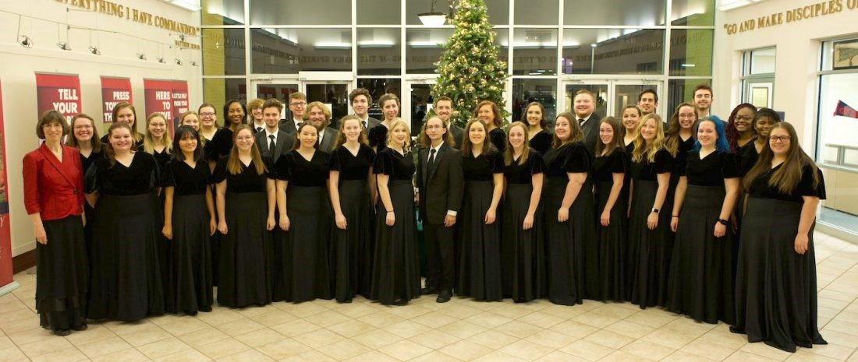

Malone University Choral Program

Saturday April 23, 2022 at 7:00 pm
The mission of the Malone University Chorale echoes the words of J.S. Bach: “The aim and final reason for all music should be nothing else but the glory of God and the refreshment of the spirit.” Through intense rehearsal and performance, the Chorale is motivated to prepare well and strive for excellence with a desire to make music that is an offering to the Lord. The Chorale functions in a way that seeks to represent the body of Christ. Its members strive to be Christ-like, serving and encouraging each other and those they meet.
The Malone University Chorale is a mixed chorus dedicated to the performance of sacred choral music reflecting diverse composers and cultures. Under the direction of Dr. Marin Jacobson, they are known throughout the United States and Europe for their high level of musical excellence. Members representing many paths of study are selected by audition each academic year.
The Chorale has performed domestically and internationally with destinations in Canada, Europe, Asia, and Latin America. Performance highlights include collaboration with the Canton Symphony Orchestra (Mahler’s Second Symphony and Brahms’ Ein deutsches Requiem), the Tuscarawas Philharmonic Symphony, and the beloved Christmas at Malone tradition. The Chorale was also the featured choral ensemble at the 2015 national conference of the Christian Fellowship of Art Music Composers.
- Hector Oliveira, internationally acclaimed concert organist
May 20, 2022 at 7:00 pm

